Pressure-Instrumented Treadmills

Record and analyze gait, run, stance, and balance with these pressure-instrumented treadmills manufactured by h/p/cosmos. h/p/cosmos has been a leader in producing high quality treadmills for over 30 years. These treadmills are designed to last with functionality, precision engineering and safety for coaches, patients and physicians worldwide.

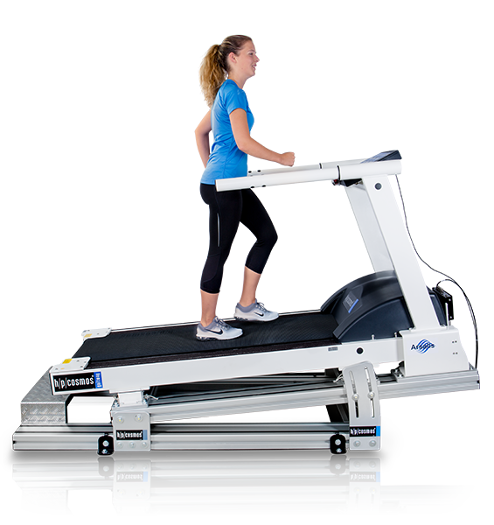
High performance treadmills
High Resolution Pressure
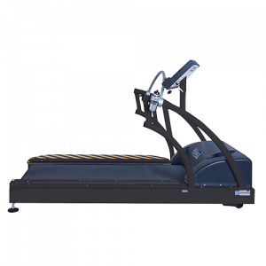
Multi-device integration capability

KinTread
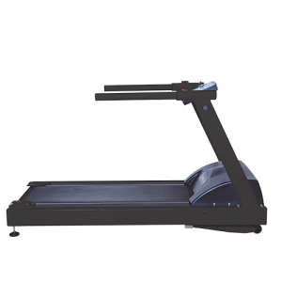
Analyze force and pressure distribution during standing, walking, and running

PhysTread
The perfect force and pressure treadmill for clinical and rehab settings
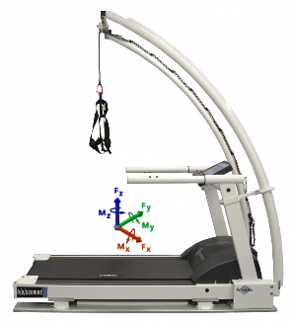
Gaitway 3D Force/Pressure Treadmill

This treadmill provides 3D force and pressure metrics on a single belt treadmill

