Toggle presses with round ram

The accessories

APK T range
The extra-powerful hand-operated toggle presses of the APK T 3
and APK T 4 ranges are especially suitable for the frequently changing applications in modelmaking and in the workshop. Their high forces of up to 30 kN enable them to be flexibly used for widely differing applications.

The advantages:
 Choice of different stroke lengths
 Extra-stable press base design
 Daylight easily adjustable by means of the standard press head threaded spindle height adjustment
 The nominal force of the press can be achieved with moderate applied force

XL-APK T range with 250 mm throat
A larger throat is required wherever bulky parts are processed, e.g. the processing of printed circuit boards, sheet metal and similar parts. mäder XL presses with 250 mm throat are employed in such cases. The base is a stable welded structure to which different standard press heads can be fitted.

E
Standard

E
M 8

35 kN
10

30 kN

25 kN

20 kN

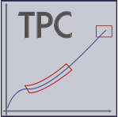15 kN

10 kN

5 kN

0 kN

Manual force: 120 N:
 APK T 3-40
 APK T 3-60
 APK T 4-30

Manual force: 225 N:
 APK T 3-S-40
 APK T 3-S-60

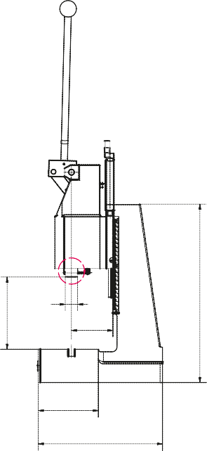10,0 mm 9,0 mm 8,0 mm 7,0 mm 5,5 mm 4,5 mm 4,0 mm 3,0 mm 2,0 mm 1,5 mm 0,5 mm 0,0 mm
vor Hubende
E
F
A
D
G

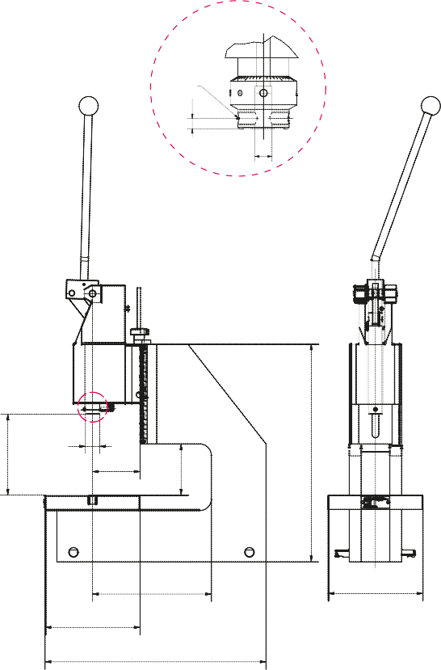With DP
APK T 3-S-40
APK T 4-30
APK T 3-S-60
APK T 3-40
APK T 3-60
E
M 8
E
Before end of stroke
XL models
E
F
A
H
C
D
G
6,25

12
B
BB
K
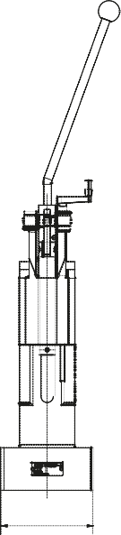
C

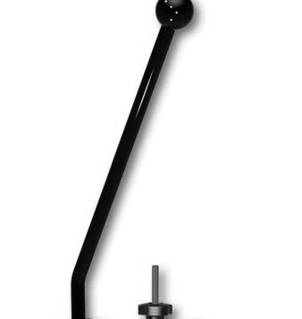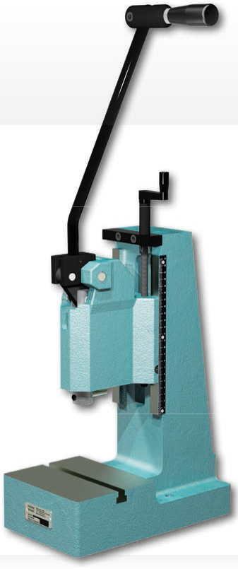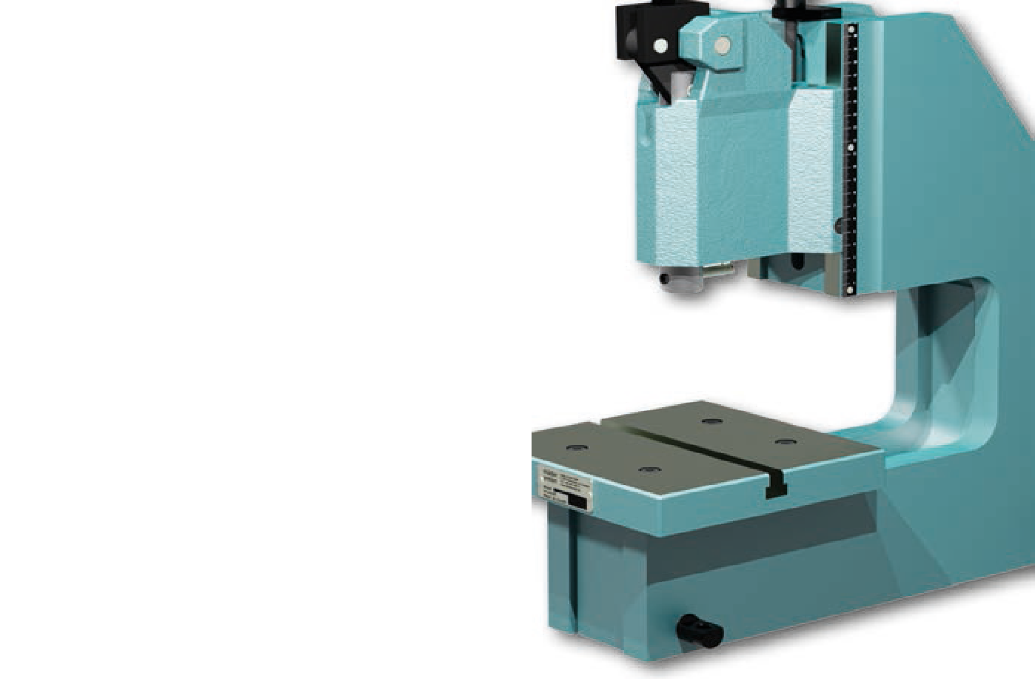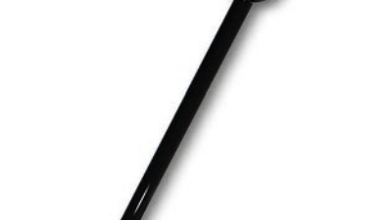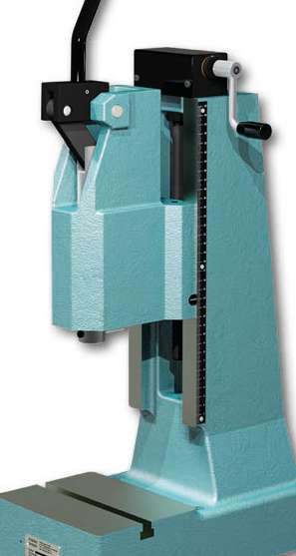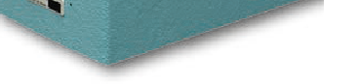equipped with ERGO hand lever*
APK T range
XL-APK T range with 250 mm throat
APK T 3-40
APK T 3-S-60
XL-APK T 3-40

Type |  |  | APK T3-40 | APK T3-60 | APK T3-S-40 | APK T3-S-60 | APK T4-30 | XL-APK T3-40 | XL-APK T3-60
Capacity |  | kN | 15.0 | 15.0 | 25.0 | 25.0 | 30.0 | 15.0 | 15.0
Working stroke |  | mm | 40 | 60 | 40 | 60 | 30 | 40 | 60
Throat | A | mm | 100 | 100 | 100 | 100 | 100 | 100 | 100
Throat C-frame | H | mm | - | - | - | - | - | 250 | 250
Daylight | B | mm | 49 - 168 | 51 - 172 | 60 - 290 | 65 - 295 | 55 - 285 | 88 - 166 | 90 - 168
Daylight with DP | B | mm | 35 - 154 | 30 - 151 | 46 - 274 | 44 - 274 | 34 - 264 | 72 - 150 | 69 - 147
Daylight C-frame | BB | mm | - | - | - | - | - | 100 | 100
Table size | CxD | mm | 175 x 140 | 175 x 140 | 185 x 145 | 185 x 145 | 185 x 145 | 200 x 200 | 200 x 200
T-slot width similar to DIN 650 |  | mm | 12 | 12 | 12 | 12 | 12 | 12 | 12
Ram bore Ø x Depth | E | mm | 10H7 x 30 | 10H7 x 30 | 10H7 x 30 | 10H7 x 30 | 10H7 x 30 | 10H7 x 30 | 10H7 x 30
Ram bore Ø x Depth with DP |  |  | 10H7 x 25 | 10H7 x 25 | 10H7 x 25 | 10H7 x 25 | 10H7 x 25 | 10H7 x 25 | 10H7 x 25
Ram Ø | F | mm | 30 | 30 | 30 | 30 | 30 | 30 | 30
Space requirement | CxG | mm | 175 x 300 | 175 x 300 | 185 x 320 | 185 x 320 | 185 x 320 | 200 x 465 | 200 x 465
Stand height | K | mm | 425 | 425 | 520 | 520 | 520 | 465 | 465
Weight |  | kg | ca. 39 | ca. 43 | ca. 58 | ca. 63 | ca. 63 | ca. 54 | ca. 58

Accessories (see Page 8-9) |  | Please specify when ordering.
Precision ram adjustment |  |  | DP | DP | DP | DP | DP | DP | DP
Return travel lock |  |  | HS | HS | HS | HS | HS | HS | HS
Counter |  |  | Z | Z | Z | Z | Z | Z | Z
Table bore 12H7 |  |  | TB | TB | TB | TB | TB | TB | TB

*Not included. Accessories must be ordered separately.
13
Toggle presses

